PHY1010 Readings & Assignments: Week 3

Week 3 Reading
Complete the following reading early in the week:
- Week 3 online lectures
From the assigned textbook Physics, read:
- Application of Newton's Laws
  - Translational Equilibrium
  - Connected Objects
  - Circular Motion
- Two-Dimensional Kinematics
  - Motion in Two Dimensions
  - Projectile Motion: Basic Equations
- Rotational Dynamics and Static Equilibrium
  - Angular Position, Velocity and Acceleration
- Rotational Dynamics and Static Equilibrium
  - Torque
  - Torque and Angular Acceleration
- The page titled 'Circular motion' from the web site http://mcasco.com/p1cmot.html

Week 3 Assignments Overview
Assignment Summary | Due Date
Assignment 1: Discussion Questions | Friday, November 27, 2009
Assignment 2: Quiz | Sunday, November 29, 2009
Assignment 3: Circular Motion Exercise | Sunday, November 29, 2009
Assignment 4: Projectile Motion Experiment | Monday, November 30, 2009
Assignment 5: Inclined Plane Experiment | Tuesday, December 1, 2009
Remember that all Assignment details can be found on the assignment pages located throughout the week. Go to those specific pages for direction on how to complete each individual assignment.

Week 3 Overview

Learning Outcomes
- Apply motion theory to object manipulation through in-class experiments.
- Able to apply the following basic principles of physics to everyday phenomena:
  - Collisions and impulse.
  - Rotation and rolling.

Forces in Two Dimensions
So far you have dealt with single forces acting on a body or more than two forces that act parallel to each other. But in real life situations more than one force may act on a body. How are Newton's laws applied to such cases? We will restrict the forces to two dimensions.
Since force and acceleration are vectors, Newton's law can be applied independently to the X and Y-axes of a coordinate system. For a given problem you can choose a suitable coordinate system. But once a coordinate system is chosen, we have to stick with it for that problem. The example that follows shows how to find the acceleration of a body when two forces act on it at right angles to each other.

Example 3.1:
A 15 kg wheelbarrow is pushed with a force of 45 N. Suppose another person pulls the wheelbarrow simultaneously with a force of 60 N, in a direction perpendicular to the first force. What is the acceleration of the wheelbarrow?
Solution:
To solve this problem we'll find the acceleration caused by each force separately by using Newton's second law and then graphically add accelerations to obtain the magnitude and direction of the resultant acceleration.
The forces are acting perpendicular to each other; therefore, we assume that the force of 45 N is along the positive X-axis and the force of 60 N is along the positive Y-axis.
Let the acceleration resulting from the force of 45 N = a_{x}, and
the acceleration resulting from the force of 60 N force = a_{y}.
Applying Newton's law along the X-axis. A force of 45 N is acting on a mass of 15 kg. So the acceleration a_{x} along the X-axis is
(45 N) = (15(kg) a_{x}
a_{x} = 3 N/kg
= 3 m/s²
Apply Newton's law separately along the Y-axis. The force in this direction is 60 N, and the mass is 15 kg. So the acceleration a_{y} is
(60 N) = (15 kg) a_{y}
a_{y} = 4 N/kg
= 4 m/s²
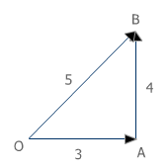
To find the resultant acceleration we draw an arrow OA of length 3 units along the X-axis and then an arrow AB of length 4 units along the Y-axis. The resultant acceleration is the arrow OB with the length of 5 units. Therefore the acceleration is 5 m/s² in the direction of OB. Also when you measure the angle AOB with a protractor, we find it to be 53°.

The acceleration caused by the two forces is 5 m/s² at an angle of 53°.

Uniform Circular Motion

When an object travels in a circular path at a constant speed, its motion is refered to as uniform circular motion, and the object is accelerated towards the center of the circle. If the radius of the circular path is r, the magnitude of this acceleration is a_{c} = v² / r, where v is its speed and a_{c} is called the centripital acceleration. A centripetal force is responsible for the centripetal acceleration, which constantly pulls the object towards the center of the circular path. There cannot be any circular motion without a centripetal force. Let's look at an example.

Example:
A stone of mass 0.2 kg is whirled by a string tied to it in a horizontal circle with a radius of 50 cm at a uniform speed of 4 m/s. What is the centripetal acceleration and the centripetal force?

Solution:
Centripetal acceleration a_{c} = v² / r

Here, the speed v of the stone is 4 m/s and the radius of the circle in which it is traveling is 0.5 m.
a_{c} = v² / r
= (4 m/s)² / (0.5 m)
= 16 m²/s² / (0.5 m)
= 32 m/s²
The centripetal acceleration is 32 m/s².

From Newton's law Centripetal Force = Mass x Centripetal Acceleration
The mass of the stone is 0.2 kg and the centripetal acceleration is 32 m/s².
Centripetal Force = 0.2 (kg) x 32 (m/s²)
= 6.4 kg m/s²
= 6.4 N

When a car takes a turn, the friction between the tires and the road provides the centripetal force. Therefore it is difficult to negotiate a turn at a high speed particularly when the road is wet and slippery. The friction is not enough to provide the centripetal force needed to keep the car in its circular path, and the car skids.

Banking
When there is a sharp turn in the road or when a turn has to be taken at a high speed as in a racetrack, the outer part of the road or the track is raised from the inner part of the track. This is called banking. It provides additional centripetal force to a turning vehicle so that it doesn't skid.
The angle of banking is kept just right so that it provides all the centripetal force required and a motorist does not have to depend on the friction force at all.

Click to explore:Forces in a carousel http://physics.uwstout.edu/physapplets/a-city/physengl/carousel.htm

Inclined Planes

Forces on an Inclined Plane
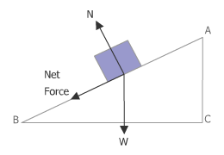
The inclined plane is a device that reduces the force needed to lift objects. Consider the forces acting on a block on an inclined surface. The inclined surface exerts a force N on the block that is perpendicular to the incline. The weight force W points downward. If there is no friction, the net force acting on the stone is the resultant of N and W. By Newton's second law the net force must point down the incline because the block moves only along the incline and not perpendicular to it.
The vector triangle shows that the magnitude of the net force is always less than the weight W.

Projectile Motion
When a ball is thrown or a shell is fired from a gun at an angle to the horizontal, the ball or the shell follows a curved path known as a parabola. The motion is in two dimensions and is called projectile motion. The moving object is called a projectile.
The vertical motion and horizontal motion can be analyzed separately for a projectile. The horizontal direction can be the x-axis and the vertical direction the y-axis.

Vertical Motion
In the vertical direction only the force of gravity acts on the projectile. The vertical motion of the projectile is the same as the motion of an object thrown vertically upward with the same initial vertical velocity.
If u_{y} is the initial vertical component of velocity, the projectile will reach a maximum height of H = u_{y}² / (2 g), which is the maximum height reached by an object thrown vertically upward with velocity u_{y}.
The time for which the projectile remains in flight is again determined by the initial vertical component of velocity and is given by T = 2 u_{y} / g, which is also the total time for which an object thrown vertically upward with velocity u_{v} stays in the air.

Horizontal motion:
In the horizontal direction there is no force acting on the projectile. So by Newton's law there is no acceleration in the horizontal direction. If the projectile is given an initial velocity of u_{x} it remains the same throughout the duration of the flight. The horizontal distance or range R that the projectile travels is given by,
R = uniform velocity x total time of flight
The total time of flight has already been stated to be 2 u_{y} / g. Therefore the range is:
R = u_{x} (2 u_{y} / g)
= 2 u_{x} u_{y} / g.
The range is determined by both the horizontal and vertical components of velocity.

Example:
A grasshopper jumps with a vertical velocity of 4 m/s and a horizontal velocity of 3 m/s. What is the maximum height it attains and how far away from the starting point does it land? (Assume g = 10 m/s²).
Solution:
The maximum height H = u_{y}² / (2 g). The vertical velocity is u_{y} =4 m/s.
H = u_{y}² / (2 g)
= (4 m/s)² / (2 x 10 m/s²)
= 0.8 m
The range of a projectile R = 2 u_{x} u_{y} / g.
u_{x} is 3 ms and u_{y} is 4 m/s. Therefore,
R = 2 x 3 (m/s) x 4 (m/s) / (10 m/s²)
= 2.4 m
The grasshopper jumps to a height of 0.8 m and a distance of 2.4 m.
A game on projectile motion - http://library.thinkquest.org/2779/Balloon.html

Rotational Motion
The CD drive in your computer makes the CD spin at a high rate to either read or write data. This is an example of rotation about a fixed axis. Until now, we have dealt with objects that translate or move along a straight or curved path.
Just as the motion along a path is described in terms of distance, speed, and acceleration, rotational motion is measured in terms of the angular position, speed, and acceleration of a body.
Angular Displacement, Velocity and Acceleration
Angular displacement is the angle through which a body rotates and is measured in degrees or radians. When a body makes one full rotation its angular displacement is 360° or 2 π (6.28 radians) radians. A radian is approximately 57.3°.
A rotating rigid body has an angular speed. For translation, speed is the rate at which distance is covered. Angular velocity is the rate at which the angular position of the body changes.
If the angular velocity of a body changes, the body has an angular acceleration. Angular acceleration is the rate at which angular velocity changes.

Torque
When the doorknob is pushed or pulled, the force rotates the door about its hinge. The turning action depends on the product of the force component perpendicular to the lever arm and the lever arm. This quantity is called torque and its units are N m. Torque may be written in two equivalent ways:
Torque = Force perpendicular to lever arm x length of lever arm
= Force x Perpendicular distance from the axis of rotation to the line of action of the force.

Newton's Law for Rotation
Newton's second law, F = m a, is for translation. For rotation the Newton's law is τ = I α
In this equation
τ is the torque,
I is the rotational inertia of the rigid body, and
α its angular acceleration.
A pair of dumbbells that has its two masses farther away from each other, is much more difficult to twist than one in which the masses are close together. Rotational inertia depends not only on the mass of the object, but also on how this mass is distributed about the axis of rotation.

Weekly Summary
This week covered forces in two dimensions, circular motion, inclined planes, projectiles, and rotation. You learned how to apply Newton's laws in situations with different types of motion. Relate the concepts covered in this week to more real life situations.

Circular Motion

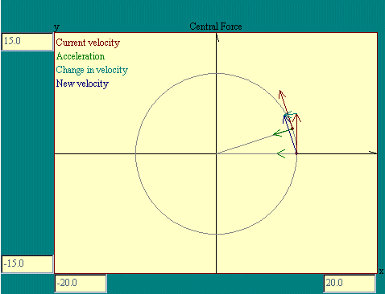
When what goes around comes around...

Imagine that a particle is subject to a force of constant magnitude but whose direction may change. The particle's acceleration at any instant would be in the direction of the force at that instant. The change in the particle's velocity over a very short time would be a vector in the direction of the average acceleration. The new velocity at the end of this tiny time interval would be the vector sum of the original velocity and the change in velocity. The displacement of the particle during the little time slice would be given by the average velocity times the Dt. Now suppose that the changing direction of the force was such that the force was always perpendicular to the velocity. The Central Force display illustrates this situation.

Notice that in this example that the force bends the path of the particle into a circle and that the force vector and therefore the acceleration always points toward the center of that circular path. The magnitude of the velocity along the path remains constant. Under these conditions the particle is said to be undergoing uniform circular motion where "uniform" means the speed of the particle is constant. We have evidently caught this system in a delicate balance where in each Dt the force deflects the particle just enough from the trajectory it would have followed, a straight line in the direction of the velocity, that it ends up on a circular path. The question now is what must be the relationship among the acceleration, velocity and radius of the circle for us to get this nice result.
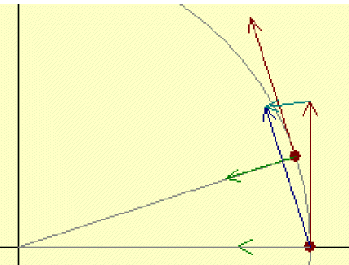
Here we are going to work some tricks that you might leave you thinking, "There is no way I would have thought of this on my own!". What we are going to do is a typical physicist's ploy of looking around for any relationship among the variables in which we are interested. Then seeing if there is any logic that leads to the relationship we want. One of the things that make this seem like magic is that we do not show you all the false leads and dead ends that were tried before this line of reasoning presented itself. The other thing is, this business gets easier with experience. Having worked out a few of these connections helps in working out new ones.
This sort of thing, by the way, drives us mathematicians crazy. We like things to follow absolutely one step after the other so that we are driven inevitably to the correct solution. This business of jumping in sort of in the middle of a problem with some idea what the answer is going to be and using a mixture of physics, logic, geometry and intuition to get a result that then may be tested by experiment is really a physicist thing.
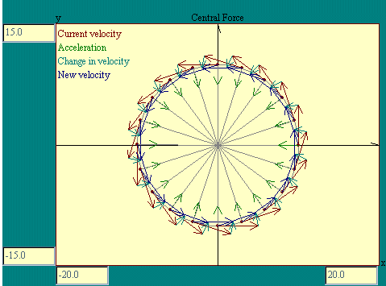
Using the image at the left, taken from the Central Force display, Take a good look at the little red/cyan/blue triangle made up of original velocity, change in velocity and new velocity vectors. A blue copy of the new velocity vector was placed at the base of the original velocity vector. Now compare that to the figure made up of the two gray radius lines and the arc included between them. Except for the fact that the second figure has a curved line for one side the two are similar triangles, meaning that the angles in the two triangles are the same. By taking Dt sufficiently small, the effect of the curvature may be made negligible.
Now the thing about similar triangles is that the ratios of corresponding sides are equal. So the ratio of the cyan side over the red side in the small triangle is equal to the ratio of the arc length over the radius in the larger figure. The length of the cyan side is the magnitude of the change in velocity, |Dv|. The length of the red side is the magnitude of the velocity, |v|. The length of the arc is the magnitude of the velocity times the time increment |v|*Dt. And the length of the gray line is just the radius of the circle, r. So we get the following relationship. |Dv| / |v| = |v| * Dt / r.
We were interested in the relationship among acceleration, velocity and radius that gave us this nice circular motion. The magnitude of the acceleration, a|, is |Dv| / Dt so let's divide both sides of the preceding equation by Dt. Then to get acceleration by itself on one side of the equation, multiply both sides by |v|. These maneuvers get us this relationship, |a| = |v|² / r, which ties together the acceleration, velocity and radius as we set out to do. Any time we find a particle in uniform circular motion it has an acceleration of magnitude |v|² / r with a direction always perpendicular to the velocity. Of course being perpendicular to the velocity which is tangent to the circle, the acceleration vector points toward the circle's center.

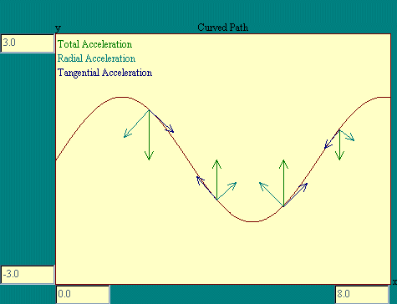
An acceleration of the sort we have been talking about, one that points toward the center of the circular motion of a particle, is called centripetal (center seeking) acceleration. Any particle whose direction is changing is undergoing a centripetal acceleration of magnitude |v|² / r where r is the radius of curvature of the particle's path. The direction of the centripetal acceleration is along the radius of curvature.
Now let's imagine a particle whose path is curved but not circular. We know that one component of the acceleration must be |v|² / r in the direction of r, where r is the radius of curvature of the path. This component of the acceleration contributes only to the change in direction of the particle since it is perpendicular to the path and therefore can not affect the speed of the particle along the path. If the total acceleration includes a component tangent to the path then the speed of the particle is affected. The Curved Path display illustrates these acceleration components. In the Curved Path display you will see the path of a particle which is moving along the x axis at constant speed and subject to a force toward the x-axis proportional to the y displacement.

Now let's go back and look at circular motion, but not uniform circular motion. Consider a weight attached to a rod of negligible mass which is suspended from a pivot so the rod and weight could swing freely in the vertical plane. The Pendulum Accelerations display shows you such an arrangement.

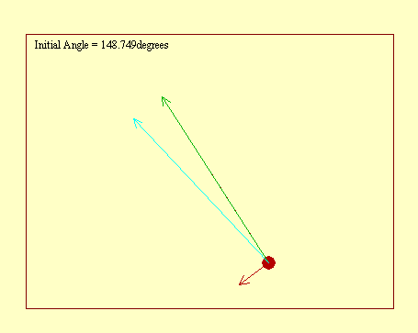
There is a lot to learn from this little pendulum display. Perhaps the first lesson is that the physics of everyday objects like a pendulum can get pretty messy, and we haven't even got to the friction part of the story yet. The second lesson is that we must pay careful attention to what we are really seeing. Because of the path and speed of the pendulum weight, we know that the radial and tangential components of its acceleration are as displayed. If they were any different the weight would have some other motion. What this display does not show you is the actual forces which result in these net accelerations. The only forces acting on the pendulum weight are gravity and the force applied by the rod. Somehow these must always add up to the total acceleration times the mass of the pendulum weight, in accordance with Newton's second law.
Near the bottom of the swing, the tension in the rod must be sufficient to both support the weight and curve its path into a circle when it is moving its fastest. Near the 180 degree position, the rod will actually go into compression, supporting the weight when its speed is near zero. You will encounter many interesting problems based on a pendulum like this. For example, what would have to be the speed of the pendulum at the top of its loop for the force exerted by the rod to be zero? Try to work this one out based on what you now understand.
In the next lesson in this course we will introduce the ideas of work and energy.

Assignment 1: Discussion Questions
By Friday, November 27, 2009 respond to the discussion questions assigned to you by the facilitator. Submit your responses to the appropriate Discussion Area. Start reviewing and responding to your classmates as early in the week as possible. You can ask technical questions or respond generally to the overall experience. Ensure to be honest, clear, and concise. Always use constructive language, even in criticism, to work toward the goal of positive progress.
Grading Criteria | Maximum Points
Correct spelling and grammar. | 4
Well-formed conclusions. | 12
Participation and feedback in discussion. | 8
Total: | 24
For assistance with any problems you may have when completing this assignment—OR—to offer your assistance to classmates, please use the Problems and Solutions Discussion area located through the left side navigation link.

Q1 - An object is projected horizontally. What are the factors on which the total time of flight depends?
Q2 - When on a merry-go-round a child experiences a force acting outward. Does this not contradict Newton's law that the force must be centripetal, that is towards the center? Explain this discrepancy.
Week 3 Quiz
- A circular disk of radius 30 cm is rotating with an angular acceleration of 1 radian/ s². What is the tangential acceleration of a point on the rim of the disk? What is its centripetal acceleration if the angular speed is 3 rev / s?
- A 980 Kg car traveling at 20 m/s rounds a curve of radius 40 m. What is the friction force that must act on the car to keep it in its circular path?
- An object with a mass of 100 Kg is dragged up an incline by applying a force F. The total distance moved along the incline is 200 m and the vertical height gained in moving this distance is 20 m. What is the magnitude of the force F if friction is negligible? (Assume g = 10 m/s²)
- What is the acceleration of an object that slides down an inclined plane that has a gradient of 1:4 (increases in height by 1 m when you travel along the plane 4 m) Ignore friction and assume g = 10 m/s².
- A torque of 5 N is applied to a door perpendicular to its face at a distance of 0.75 m from its hinge. What is the torque on the door about the hinge?
- The nut on a car wheel requires a torque of 75 N.m for opening it. A wrench 25 cm long is used to open the nut. What is the minimum force needed to open the nut?

Assignment 3: Circular Motion Exercise
By Sunday, November 29, 2009 please complete your response to the following question and post it to the appropriate Discussion Area.
When the road is wet, it is difficult to take a sharp turn without skidding. Why does this happen? At a certain sharp turn in a road there are frequent accidents. What would you suggest to make it safe for vehicles to take this turn? Support your response with appropriate sketches. Read the lectures and the textbook for more information on this topic.
Grading Criteria | Maximum Points
Demonstrate knowledge of circular motion. | 4
Suggest banking the road. | 4
Correct sketches. | 4
Total: | 12
For assistance with any problems you may have when completing this assignment—OR—to offer your assistance to classmates, please use the Problems and Solutions Discussion area located through the left side navigation link.
Assignment 4: Projectile Motion Experiment
By Monday, November 30, 2009 visit the Web page (Be certain you have the Java plugin installed in your browser. After this page opens, click on "Run Applet" in the middle of the page.) http://www.phys.virginia.edu/classes/109N/more_stuff/Applets/ProjectileMotion/applet.html, perform the following experiments online, fill in the tables, and write your own conclusions that should be posted to the appropriate Discussion Area.
Grading Criteria | Maximum Points
Filling up each table correctly | 8
Correct answers to the questions in "observation & analysis" | 12
Total: | 20
For assistance with any problems you may have when completing this assignment—OR—to offer your assistance to classmates, please use the Problems and Solutions Discussion area located through the left side navigation link.
Q1: Condition: Uncheck the air resistance checkbox.
Setting: Perform this experiment by varying the angle at least 6 times for each of the following velocities:
- 40 m/s
- 50 m/s
- 60 m/s
Record in table 1:
- The maximum distance (Range) traveled by the projectile at various angles
- The total time of flight at various angles
- The maximum height attained
Table 1: Experiment 1 - Range & Time of flight (without air resistance)
Table 1: Experiment 1 - Range & Time of flight (without air resistance)
S. No. | Initial Speed | Angle of Projection | Range | Time of Flight | Maximum Height Attained
1.
2.
3.
4.
5.
6.
Observe and Analyze:
- The angle at which the Range is a maximum.
- The angle at which the total time is maximum.
- What is the relationship you observe between the total time and the maximum height attained?

